How to create a GITHUB account?

1. Open microsoft edge and search GITHUB.COM
2. 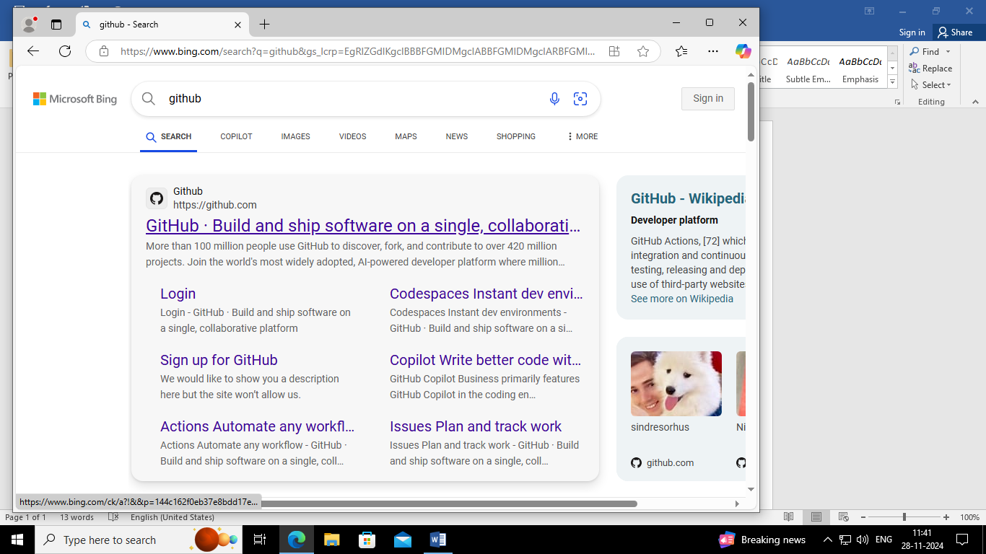
3. Click on that link
4. Sign in with your gmail
5. 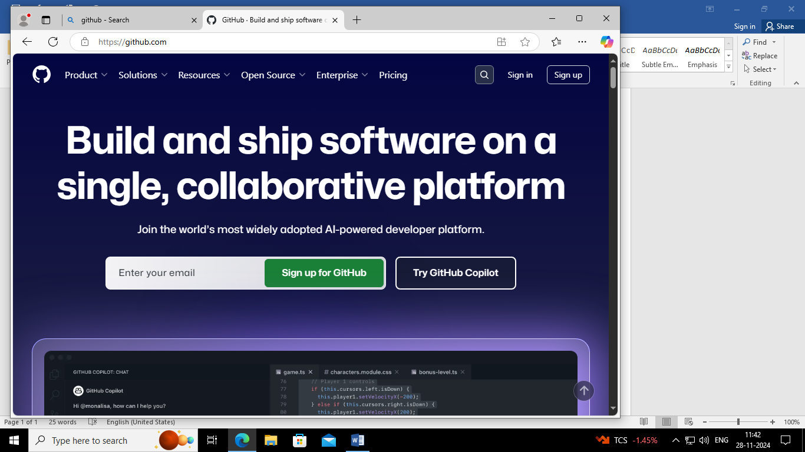
6. Enter your email and sign up for GITHUB
7. 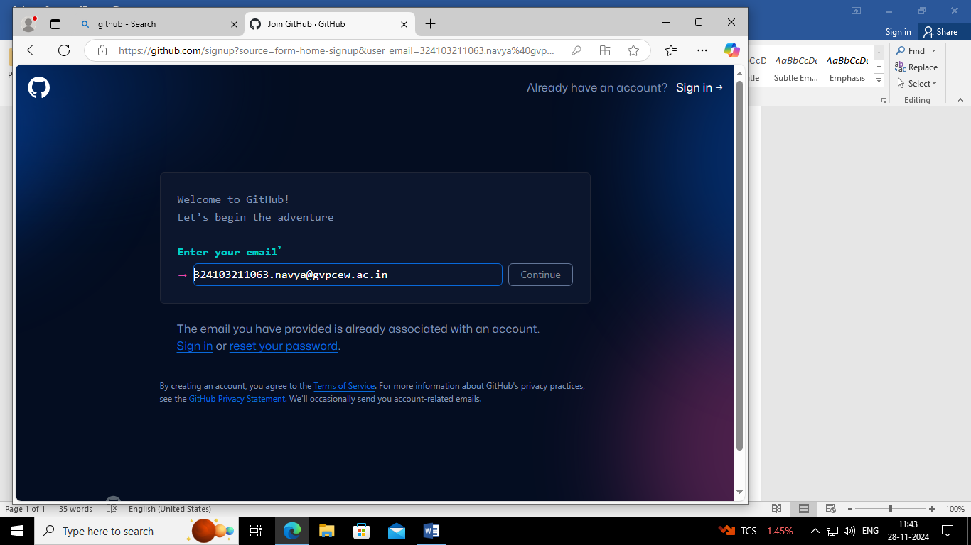
8. Create a password
9. Create a username for GITHUB account
10. Verify your account
11. Gmail gets a code enter that code
12. GITHUB account is created
13. Now sign up in GITHUB account
14. 